
Company
Logotype

Cone Beam Computed Tomography- Report



Porur Dental X-rays & CBCT

Patient Name : Mrs. Vijayakumari | Date of Report : 08.12.2024
Age/ Gender : 51 years/ Female | Region of Interest : CBCT Full Skull
Referring doctor: Dr. Mothishwaran | Indication : Implant assessment
Clinical Notes: Nil
PATIENT INFORMATION

CBCT- Full skull provided
CBCT – IMAGE DETAILS

RADIOGRAPHIC INTERPRETATION

- Completely missing crown and root in relation to 11, 14, 16, 17, 18, 21, 22, 23, 25, 26, 27, 28, 31, 32, 33, 38, 41, 42, 43, 44, 45, 46, 47, 48.
- Root stumps: 24, 36.
- Presence of bone loss extending beyond the apical third of all teeth that are present.
- Complete resorption of maxillary alveolar ridge resulting in narrow maxillary arch in anterior and posterior region causing reduced height of maxillary alveolar ridge.
- The pterygoid plates in both sides are present with normal bone density and hence can be considered for implant placement.
- The mandibular alveolar ridge is also present with resorptive changes and areas of depression thereby resulting in reduced mandibular height.
- Complete opacification of the right maxillary sinus is evident.

IMPLANT ASSESSMENT

 | 11 region | 12 region | 13 region | 14 region | 21 region | 22 region | 23 region | 24 region
Sub-Crestal | 1.5 | 1.8 | 1.8 | 1.9 | 1.3 | 1.7 | 1 | 1.5
Mid- Crestal | 1.3 | 2.9 | 2 | 2.4 | 1.8 | 1.8 | 1.2 | 1.5
Distance between the alveolar ridge and Floor of the Nasal cavity (in mm) | 6.4 | 4.7 | 7.8 | 8 | 6 | 5.5 | 5.9 | 4.7

 | 15 region | 16 region | 17 region | 25 region | 26 region | 27 region
Sub-Crestal (in mm) | - | - | - | 1.7 | - | -
Mid- Crestal (in mm) | - | - | - | - | - | -
Distance between the alveolar ridge and floor of the maxillary sinus (in mm) | 1.3 | 1 | 1.9 | 2.8 | 1 | 1.1

 | 31 region | 32 region | 33 region | 34 region | 41 region | 42 region | 43 region | 44 region
Sub-Crestal | 2.9 | 3.5 | 2.8 | 6.8 | 3.4 | 2.4 | 3.2 | 4.9
Mid- Crestal | 3.5 | 4.1 | 3.1 | 6.7 | 4.6 | 3.8 | 4.9 | 7.3
Distance between the alveolar ridge and lower border of mandible (in mm) | 16.5 | 16.9 | 16.2 | 9.2 | 15.4 | 16 | 13.6 | 12.3

 | 35 region | 36 region | 37 region | 45 region | 46 region | 47 region
Sub-Crestal (in mm) | 8.2 | 7.5 | 7.4 | 5 | 5.4 | 8.2
Mid- Crestal (in mm) | 7.5 | 8.4 | 6.7 | 7.3 | 7.9 | 9.5
Distance between alveolar ridge and the inferior alveolar nerve canal (in mm) | 8.3 | 1.7 | 7.4 | 0.8 | 0.9 | 1
Distance between the alveolar ridge and lower border of mandible (in mm) | - | 11.6 | 17.7 | 11.4 | 11 | 10.9

RADIOGRAPHIC IMPRESSION

- Partially edentulous maxillary and mandibular arch.
- Root stumps: 24, 36
- Generalized Chronic Periodontitis.
- Right maxillary sinusitis.

Kindly correlate with clinical findings


IMAGES FOR REFERENCE

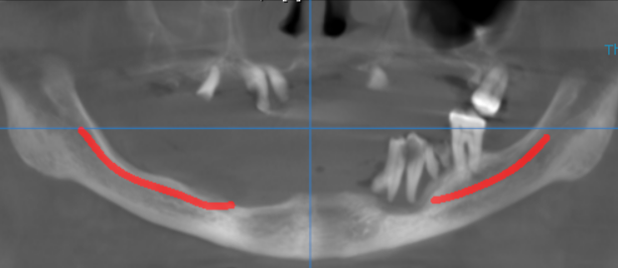

3-DIMENSIONAL VIEW

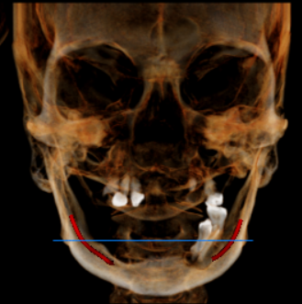

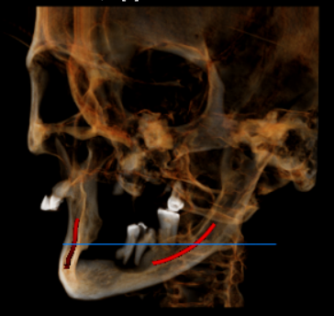
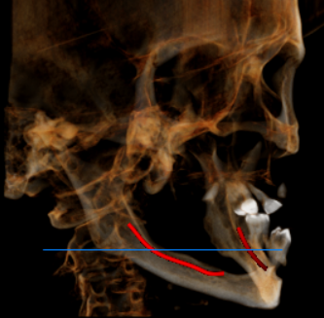

CROSS SECTIONAL VIEW

11 region | 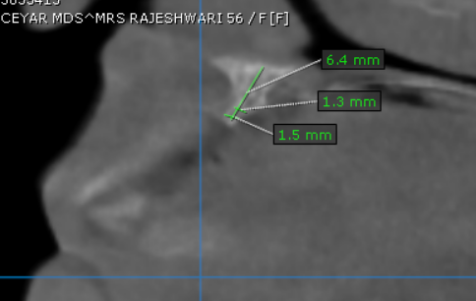
12 region | 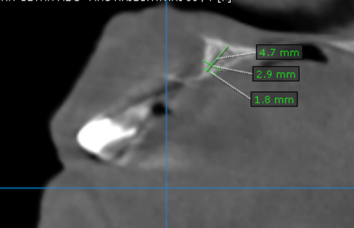
13 region | 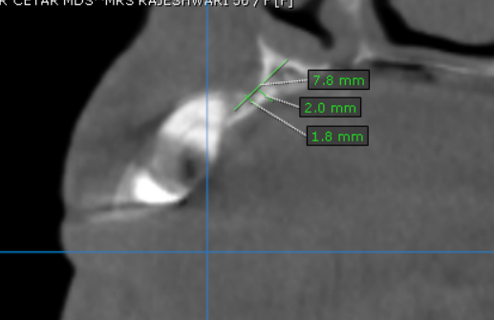
14 region | 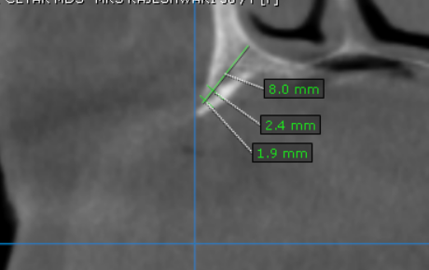
15 region | 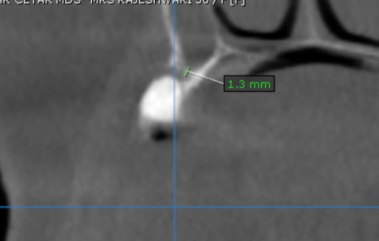
16 region | 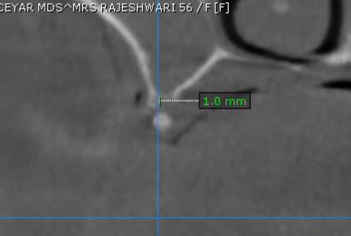
17 region | 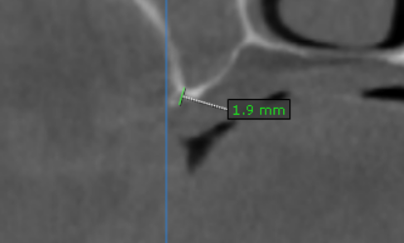
21 region | 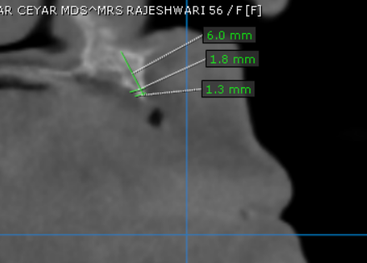
22 region | 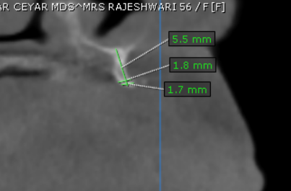
23 region | 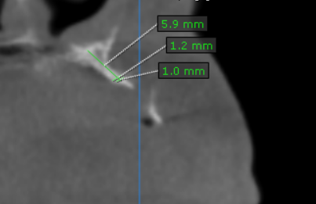
24 region | 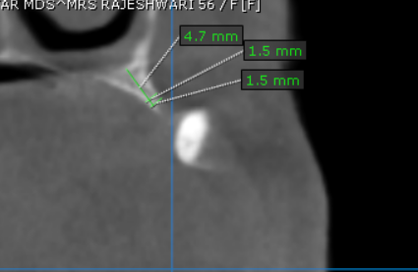
25 region | 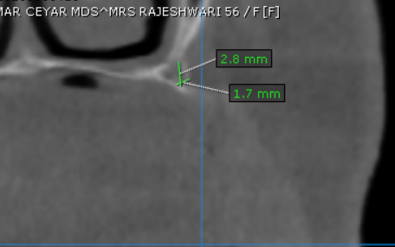
26 region | 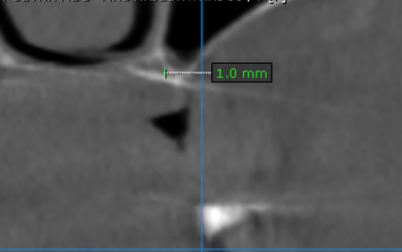
27 region | 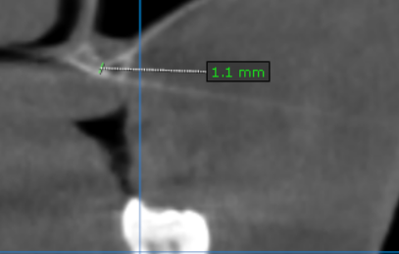
31 region | 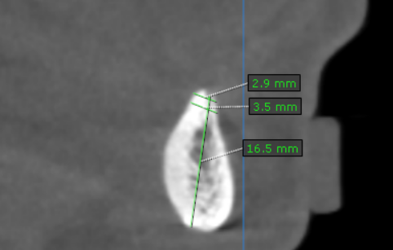
32 region | 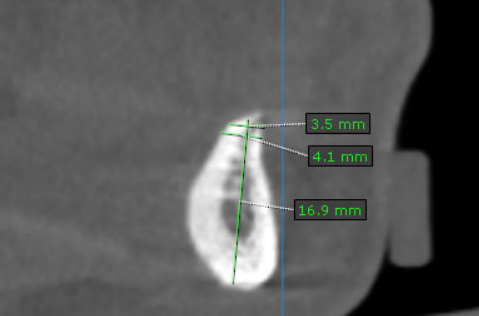
33 region | 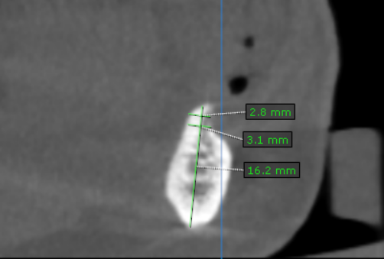
34 region | 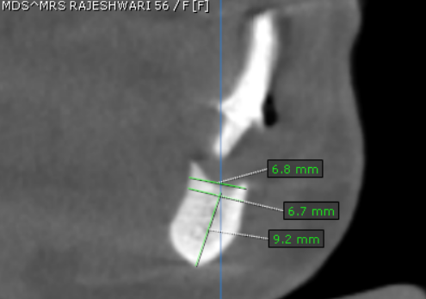
35 region | 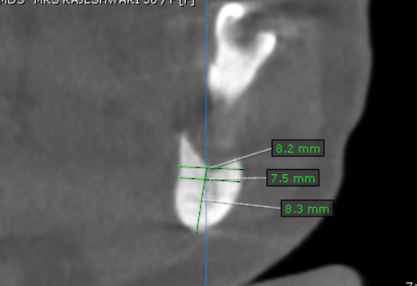
36 region | 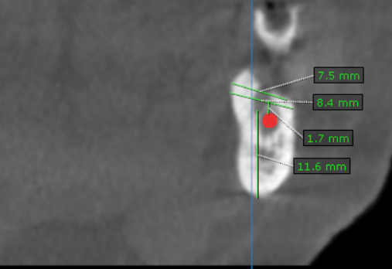
37 region | 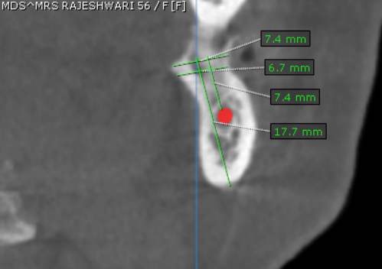
41 region | 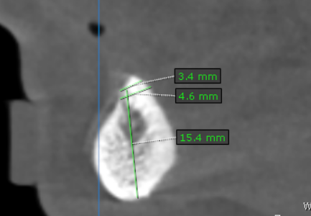
42 region | 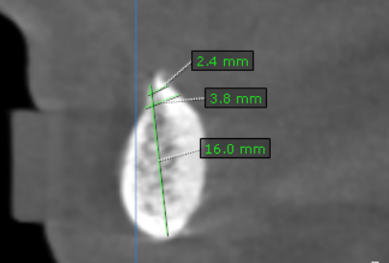
43 region | 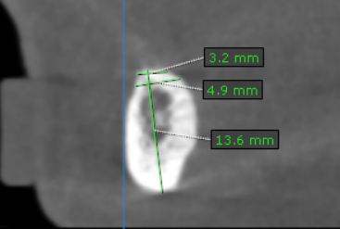
44 region | 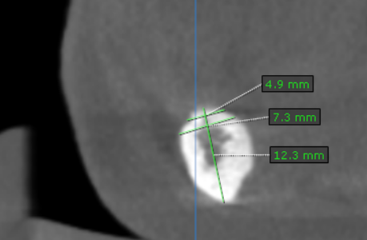
45 region | 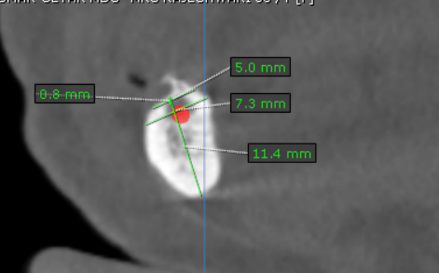
46 region | 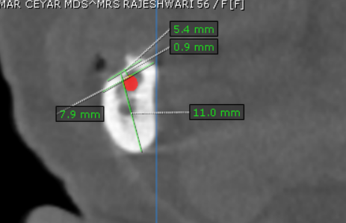
47 region | 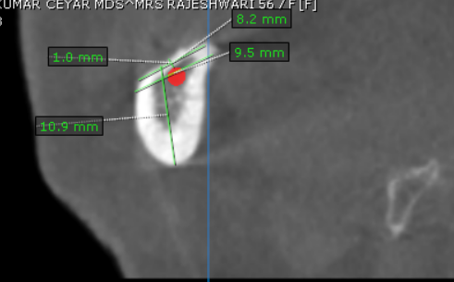

**** End of report ****

